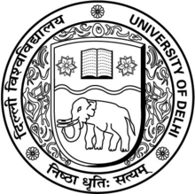
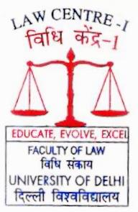
The Law Centre-i is pleased to invite papers from law students, law professors and legal professionals for the ‘Seminar on Social Justice for Women: Contemporary Issues and Challenges’ organised as part of the year long Golden Jubilee Celebrations commemorating the fifty years of Centre’s contribution to excellence in legal education since 1970. This Seminar is part of the Seminar Series on Social Justice scheduled to be held from February to November 2020. The Series has been envisioned by Justice Mr. Madan B. Lokur (Retd.), former Judge of Supreme Court; Prof. Dr Ved Kumari, Professor at Law Centre I and former Dean of Faculty of Law; and Prof. Dr Sarbjit Kaur, the Professor-in-Charge of Law Centre I with the objective of advocating and assimilating social justice issues into legal education by comprehensively discussing different themes of social justice.

Seminar on

Social Justice

for Women: Contemporary Issues and Challenges

as part of the

Golden Jubilee

Celebrations
Commemorating Fifty Years of
Law Centre I
Organised by
Law Centre I
Faculty of Law
University of Delhi
The idea of justice engages with the social aspect in a multi-layered and multi-dimensional manner. In spite of different acts and schemes of government to empower the women in the country, they are discriminated and marginalised at every level of the society, whether it is social participation, political participation, economic participation, access to education and also reproductive healthcare. Deliberating on these concerns, the Seminar Series would be held on Friday, February 7, 2020 at the Moot Court Hall, Umang Bhawan, Law Centre I:
Theme | Social Justice for Women: Contemporary Issues and Challenges
Sub-topics  (Suggestive) | - Reproductive Rights: Agency Battles  - Violence Against Women: Rape, Acid Attacks and Hurt  - Sexual Harassment: From Vishakha to Now  - Building Secure Environment for Women Prisoners  - Widows: Concerns Addressed and Unaddressed
Abstract | January 20, 2020
Communication of Selected Abstracts | January 22, 2020
Full Papers | February 4, 2020

The abstract of 500 words indicating the Seminar Theme, Title of the Paper, the key argument and five keywords are to be submitted to seminaronsocialjustice.lc1@gmail.com. Selected papers would be published as a book (with ISBN) by the Law Centre I.

Seminar Coordinators
Ms Shachi Singh Ms Shivika Choudhary Mr Piyush Kumar
Assistant Professor, Law Centre I Assistant Professor, Law Centre I Assistant Professor, Law Centre I
shachi240788@gmail.com shivika.c@nls.ac.in piyush917@gmail.com
+918860164260 +919119167222 +918860760804

