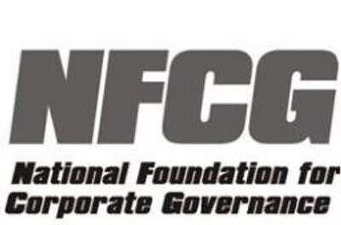

NLU Jodhpur-NFCG Conference on Corporate Law & Governance

Centre for Corporate Governance & National Foundation of Corporate Governance [NFCG]
(15-17 September, 2018)
REGISTRATION FORM
(Kindly fill and send this form to journal.governance@gmail.com on or before July 25th, 2018)

Name Mr./Ms.
Category (Student/Academician/Practitioner/Other):
Educational Qualification:
Name of College and University:
Year of Graduation:
Address:
Email id:
Mobile number:

