THE CENTRE FOR HUMAN RIGHTS AND HUMANITARIAN LAW

ICFAI LAW SCHOOL, THE ICFAI UNIVERSITY DEHRADUN

PRESENTS
NATIONAL VIRTUAL SPECIAL GUEST LECTURE
ON
GENDER JUSTICE AND GENDER EQUITY

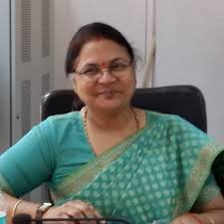
KEYNOTE SPEAKER
PROF. (DR.) PRITI SAXENA
Director, Centre of Post Graduate Legal Studies,
Ex-Head Department of Human Rights

PROF. (DR.) YUGAL KISHORE
DEAN, ICFAI LAW SCHOOL, DEHRADUN

MRS. MONICA KHAROLA
ACADEMIC COORDINATOR, ICFAI LAW SCHOOL, DEHRADUN

FACULTY COORDINATOR
MS. PRACHI MISHRA
ASSISTANT PROFESSOR, ICFAI LAW SCHOOL, DEHRADUN

REGISTRATION LINK: https://forms.gle/efhZ2cu3wjH3Say4A

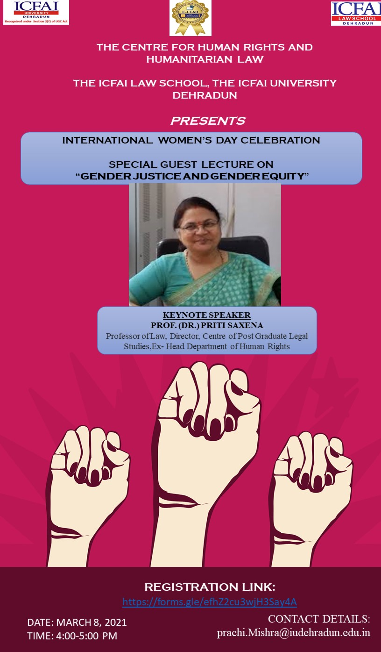

ABOUT THE UNIVERSITY
The ICFAI University, Dehradun, Uttarakhand (hereinafter referred to as the University) wasestablished under the ICFAI University Act 2003 (Act No.16 of 2003) passed by the Uttaranchal Legislative Assembly and assented to by the Governor on July 08, 2003.
The ICFAI University secured 44th rank in the World Universities with Real Impact (WURI) Rankings 2020 released by UN Institute for Training and Research. ICFAI is the only non- governmental institution among two Indian Universities in this list. The University has also been awarded with the certificate for E- Learning Excellence of Academic Digitisation (e- LEAD).

ABOUT ICFAI LAW SCHOOL, DEHRADUN

ICFAI Law School (formerly known as Faculty of Law), a constituent of the ICFAI University,

Dehradun is established with the objective of developing a new generation of legal professionals

through the comprehensive and contemporary body of knowledge integrating law with

Management/Humanities. The Bar Council of India has accorded its approval for imparting three

year and five year Law Courses at ICFAI University, Dehradun, Uttarakhand and award degrees in law

The ICFAI Law School, Dehradun is the 6th Ranking Law School of Super Excellence and 1st Ranking Law School in Uttarakhand according to CSR GHRDC Law School Rankings 2020. It also secured 26th rank among top Law Universities/ Institutions including NLUs in MDRA Rankings 2020 conducted by India Today.

ABOUT THE CENTER FOR HUMAN RIGHTS AND HUMANITARIAN LAW
The ICFAI Law School, The ICFAI University Dehradun has established the Center for Human Rights and Humanitarian Law in the year 2020, which would focus on providing students, academicians and wider community with a locus of intellectual and physical resources for engaging critically with how law impacts upon some of the compelling social problems of our modern era. The center aims to provide legal assistance to the vulnerable groups who has been legally, socially or economically exploited and discriminated in different ways. It also aims to train the law students and the community at large about the existing challenges of the pluralistic society and the rising conflicts and tensions in the name of pluralistic loyalities to caste, religion, region and culture.

About the Special Lecture
The Center for Human Rights and Humanitarian Law, The ICFAI Law School, The ICFAI University, Dehradun is celebrating International Women’s Day and is organising “The National Virtual Special Guest Lecture on Gender Justice and Gender Equity” on 8th March,2021 (4:00PM-5:00PM).
Speaker:
Prof. (Dr.) Priti Saxena- Professor of Law, Director, Centre of Post Graduate Legal Studies, Head Department of Human Rights, Babasaheb Bhimrao Ambedkar University.

Target Audience:

Students, Research Scholars and Academicians

Venue:
Zoom Platform
Registration
No Registration fee
Certificate shall be provided to all the participants

Contact Details
Email Id: prachi.mishra@iudehradun.edu.in

