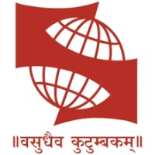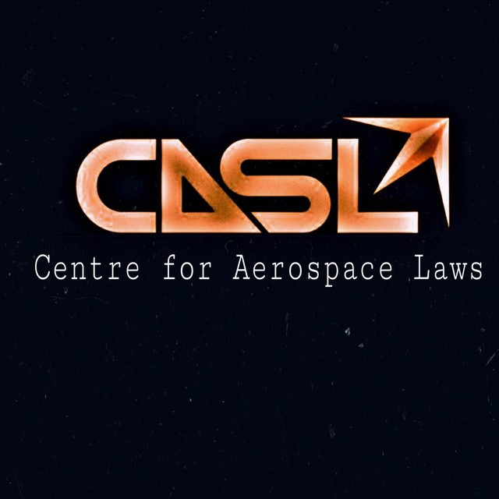

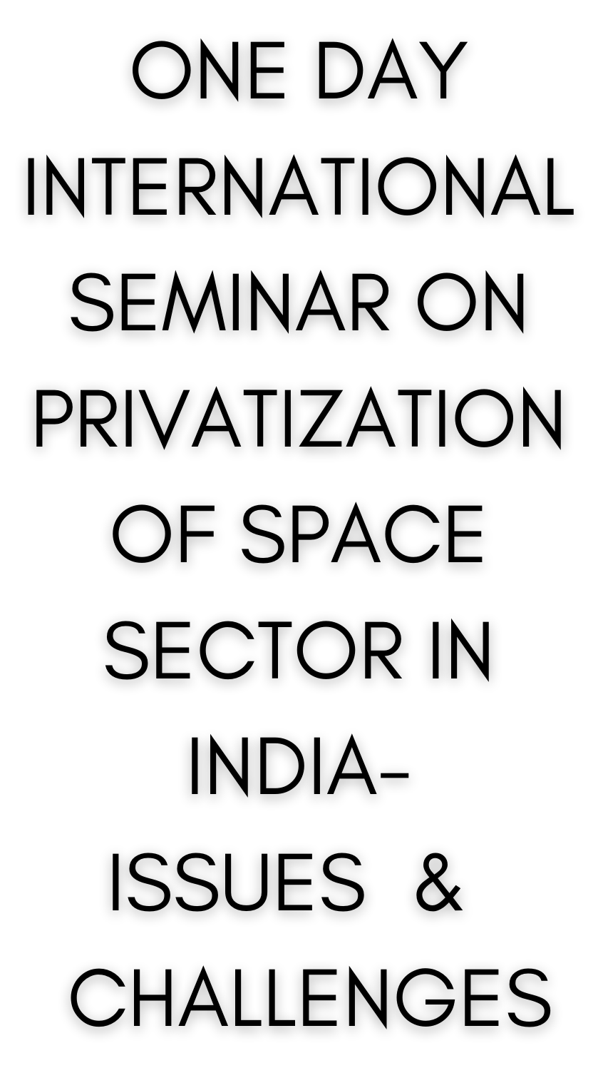
CENTRE FOR AERO- SPACE LAWS,
SYMBIOSIS LAW
SCHOOL, HYDERABAD IN COLLABORATION
WITH
LAW MANTRA AND INTERNATIONAL
COUNCIL FOR JURISTS
TIMELINE:
Registration Commences: 20.12.2020
Abstract Submission: 10.01.2021 Selection of Abstracts: 15.01.2021 Registration Ends: 25.01.2021 Submission of Final Paper: 25.01.2021 Date of Seminar: 06.02.2021

REGISTRATION FEE:
There will be no Registration Fee for the Faculty, Research Scholars and Law Students of Symbiosis International University and its Constituent Law Schools.
For Others,
Single Author – INR 500/- Co- Author - INR 1000/- Research Scholars INR 600/-
International Participant - $ 10/- (Academician, Students, Research Scholars)

CONTACT:
Dr. Shailendra Kumar: +91 98313 92831
Arunabh: +91 79017 74426
Email ID: casml@slsh.edu.in

ABOUT THE SEMINAR
Centre for Aero-Space Law, Symbiosis Law School Hyderabad, Law Mantra and International Council of Jurist is jointly organizing a one-day International Seminar on “Privatization of Space Sector in India- Issues & Challenges” on 06th February 2021.
The Centre is making an endeavor to explore new arenas and dimensions of this newly emerged field. Many notable personalities from the sphere of aerospace law will attend the Seminar to share their views, experiences, and expertise on the topics.
Through this Seminar we endeavor to generate an interest in aerospace law, the present issues which plague, if the space sector in India is privatized and how law plays a role in the same.
The main objective of this Seminar is to have a pertinent enlightenment on the themes and sub-themes of this emerging arena through the contribution of legal luminaries, delegates and participants from academia and persons from the legal field.
OBJECTIVE
The Object of the seminar is bring policy maker, stake holder and academia to discuss the Present and future legal and regulatory challenges. The Indian space sector may have open today to the private sector, however commercialization and private participation started long back when Antrix Corporation Ltd (1992) was established. Now, the goal is to commercialize Indian space sector through the entrepreneurship, investment and active participation of stakeholders. The government of India has created Indian National Space Promotion and Authorisation Centres (IN-SPACe) to provide a level playing field for private companies to use Indian space infrastructure.
WHO CAN PARTICIPATE?
Students, Scholars, Professional, Academic Community from any countries with interest in the given themes are invited to participate in the Seminar and present their paper.
CO-AUTHORSHIP:
Co- Authorship up to a maximum of 2 authors shall be allowed.
SUB-THEMES:
Space Sector in India: Opportunities and Challenges Indian Regulatory Authority and Procedure
State Responsibility, Jurisdiction and Control
Liability for Private Space Activities: Concerns in India
Mining Space Resources
Financing Private Space Activities in India

FORMATTING GUIDELINES:
- Main Text: Times New Roman, Font Size 12, Line spacing 1.5 points
- Footnotes: Times New Roman, Font Size 10, Line Spacing 1.0 points
- Margins: 1 inch on all sides
- Citation Style: 20th Edition Bluebook Citation System
- Word Limit: Maximum 10,000 (inclusive of footnotes)

PRESENTATION GUIDELINES:
The presentation shall be made oral through Power Point presentations, e- posters or through exhibits. The power- points should be mailed to casml@slsh.edu.in by 25th January 2021

GENERAL GUIDELINES:
Registration Details shall be intimated after Abstract Selection.
Plagiarized entries shall be liable for rejection.
The submissions should be devoid of any copyright issues i.e., it should not be submitted and published in any other place. The authors of selected paper shall have to sign an undertaking stating that the paper is not published in any other place and that it is an original piece of work.
The editors reserve the right to delete or edit any article or part thereof whose content is found to be offensive, defamatory, out rightly unethical, or if it is suggestive of untrue facts of racism, sexual or religious discrimination, illegal or terror, activities etc. Grammatical & Punctuation mistakes shall not be overlooked.
The sole decision of selection of final paper shall lie with the Editor and Centre Authorities. The authorities reserve the right to intimate corrections to the authors. The best papers of the Seminar will be rewarded and published theme wise, in a book with ISBN Number or as Special issue of Symbiosis Law Journal.
Each participant shall receive participation certificate, duly signed by the authorities.
HOW TO SUBMIT ABSTRACT?
The abstract should not exceed 500 (Five Hundred only) words.
The Abstract must be accompanied by a cover page, stating the following- Sub-Theme(write “others” in case it is not mentioned in sub- theme); Title of the paper; Name of Author(s); Name of Institute/ Organization; Official Designation; E-mail Address; Postal Address and Contact Number.
The Subject of the Mail should be “Abstract Submission for-Theme- Subtheme-name of author”.
The word folder containing the abstract should have the name of the author and title of paper.
Abstract should have minimum three and maximum four Key Word.
The submission should be in word and pdf will not be accepted.
Selection of Abstract will be notified on 15 January, 2021.
After Selection, a detailed mail regarding the registration process will be send i.e. Registration Form along with a detailed note on Final- Paper Submission.

Chief Patron: Prof. (Dr.) Sarfaraz Ahmed Khan
Director, Symbiosis Law School, Hyderabad

Patron: Prof. (Dr.) Anuradha Binnuri.
Deputy Director – Symbiosis Law School, Hyderabad

Advisor to Organising Committee Dr. Sandeepa Bhat B
Professor of Law, WBNUJS, Kolkata

Organizing Committee Dr. Shailendra Kumar
Assistant Professor (In charge, CASL) Symbiosis Law School, Hyderabad

Mr. Kishor Mishra, President Law Mantra

Dr. Adish C. Aggarwala (President) International Council of Jurists, London

Student Convenor: Anushka Misra Student Co-convenor: Khushi Kerur (President, CASL, SLSH)

