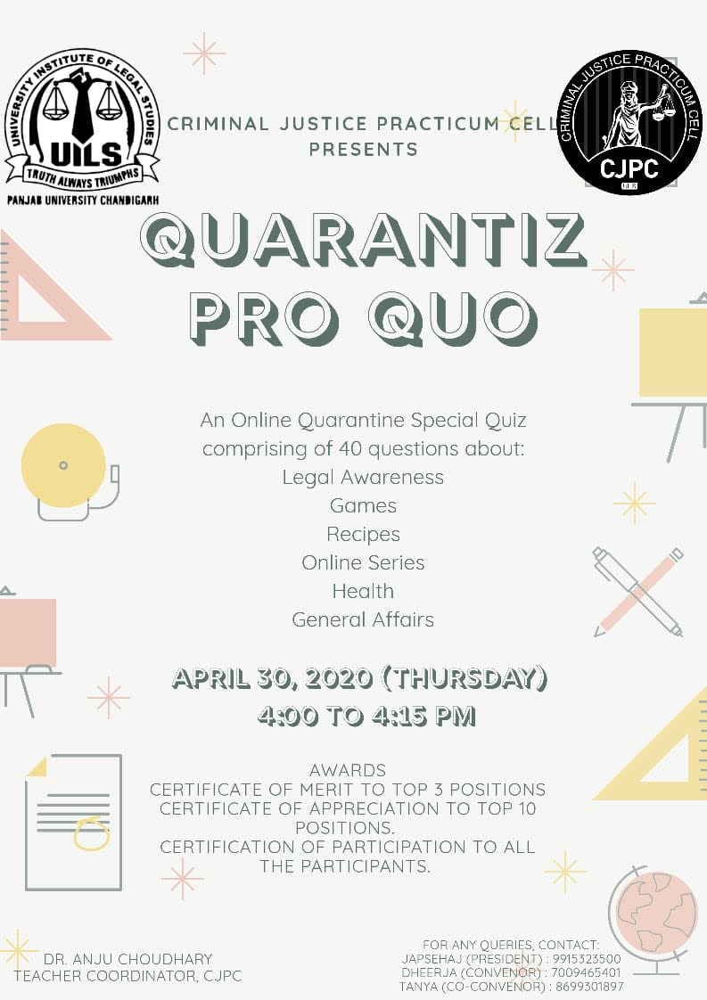

ABOUT UILS

University Institute of Legal Studies (UILS) was established as constituent department of Panjab University, in the academic session 2004-05. During a short span of time, it has emerged as one of the premier legal Institute with a unique blend of tradition and modernity. Its mission is to equip the students with the skills to comprehend and diagnose the intricacies of various legal and other inter-disciplinary issues and devise solutions to these problems through analysis and reasoning. The stimulating and interactive academic environment of the Institute helps to hone the 'DRAIN' .Drafting, Research, Advocacy, Interviewing and Negotiation- skills of the students. To accomplish this, the Institute arranges a number of curricular and extra-curricular activities. Students are trained in essence of the substantive laws, techniques of procedural laws, methods of client counselling and skills in legal and social sciences research etc. The Moot Court Competitions, Client Counselling Sessions, Quiz Contests, Seminars, Group Discussions and Extension Lectures etc. are a regular feature of the academic calendar of the Institute. The Institute also exposes its students to the 'law in action' through compulsory internships with Hon'ble Judges of Supreme Court, Punjab and Haryana High Court, eminent lawyers, legal firms, various commissions and NGOs, etc.

ABOUT CJPC

Criminal Justice Practicum Cell (CJPC) is an applied learning programme for the youth so as to understand the depth of criminal justice system through real world experience. It is an essential first step in entering the world which will help the students to enhance skills and refine their career goals and plans. CJPC’s agenda is to expand and enrich student understanding of the criminal justice system. It will supplement the traditional classroom teaching with some real life intern experience. It will help the students to develop professional knowledge.

CRIMINAL JUSTICE PRACTICUM CELL
PRESENTS
QUARANTIZ PRO QUO

GENERAL RULES:
- The competition is open for students pursuing a Bachelor'/Master's degree from any UGC recognized educational institution in any field.
- The competition is subject to individual participation by mode of online registration.
- Any kind of discrepancy in the registration process may lead to cancellation of registration.
- All the participants are requested to provide the contact number which is registered on WhatsApp for the formation of WhatsApp group.
- The registered candidate will be added automatically to the group by the CJPC.
- The quiz will be held on 30th April, 2020 from 4:00 PM to 4:15 PM.

MODE OF PLAY:
- The quiz will be played via Google Forms.
- The Link for the quiz will be sent on the WhatsApp Group so formed by the CJPC for the quiz.
- The quiz can be played on any device- Mobile/Tablet/Laptop.
- CJPC will not be responsible in case of any connectivity/device failure during the Quiz.

REGISTRATION:
- The Registration for the Quiz can be done by clicking at https://forms.gle/jwtb7hg6tQgyidAC7.
- The Quiz is free of cost and has no registration charges.
- The Last date of registration is April 26, 2020, till midnight.
- The registration is subject to first-come, first-served basis. The CJPC holds the right to close the registration before the due date in case of overflow of registration entries.

COMPOSITION OF QUIZ
The quiz will consist of questions from the following topics:
- Legal Affairs
- Games
- Recipes
- Online Series (Amazon/Netflix, etc.)
- Health
- General Affairs
The quiz will comprise of a total of 40 questions.

PRIZES
- Top 3 winners will be awarded with the Certificate of Merit.
- Top 10 winners will be awarded with the Certificate of Appreciation.
- All the participants in the Quiz will be given the Certificate of Participation.
- The certificates will be in the form of e-certificates and will be mailed to the participants on their respective email addresses.
- The participants are requested not to ask for the hard copy of the certificate.

QUERY DETAILS
- Kindly forward your queries (if any) at: queriescjpc@gmail.com. They will be addressed at the earliest by the CJPC.

