Call for Blog-posts: The Criminal Law Blog by NLU, Jodhpur: Submission on Rolling Basis
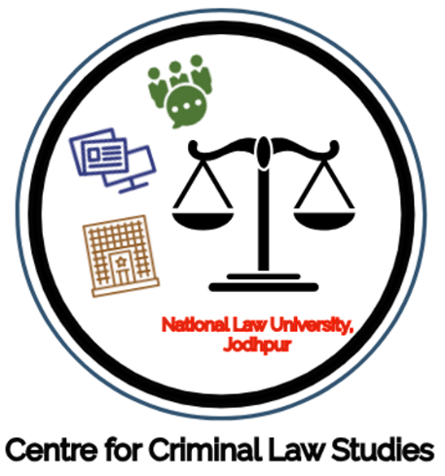

About the Centre for Criminal Law Studies
The Centre for Criminal Law Studies was established to carry out intense research work in issues pertaining to the criminal Justice System in India. In its long-term eexistence, the Centre has submitted comprehensive policy papers on Investigation and Prosecution to law reforms committee. Currently, the Centre undertakes research in specified areas; namely; Criminology, Criminal Psychology, International Criminal Law and Justice, Police Sciences, Investigation and Prison Administration. The Centre also organizes lectures on relevant issues. To this effect, the Centre works in association with the national repute institutions like Bureau of Police Research and Development in organizing the focused training programs to the specific target group of police official
Pursuant to its research mandate, the Centre started The Criminal Law Blog last year. The Blog has featured significant posts from legal practitioners, leading academicians, and students. Notably, we received submissions from a Greek judge and an American private investigator. We now invite submission from students, academicians, law practitioners, and every criminal law enthusiasts.
Themes
We welcome articles having their connections with the criminal law, especially contemporary developments and novel ideas. This includes articles on:
- Domestic Criminal Law [Substantive and Procedural]
- International Criminal Law [Substantive and Procedural]
- Interface between criminal law and other legal domains
- Legislative and Policy Analysis
- Analysis of latest judgments
- Movie Reviews
How to Submit:
- Submissions for the blog shall be reviewed on a rolling basis.
- The submission should be an original work not exceeding 1500 words. However, flexibility is allowed if the content so requires and the quality is maintained.
- All relevant sources must be duly acknowledged and hyperlinked in the text.
- The article must be submitted in a MS-Word document to blog.ccls@gmail.com.
- The cover page of the e-mail must include a brief description of the author.
- The authors are encouraged to provide a relevant photograph regarding the subject matter of the article.
- The authors shall receive an acknowledgment of the receipt of the article by the Editorial Board. The Boards shall try its best to update the authors within 14 days from the day of acknowledgment.
Detailed submission guidelines can be found here.
Note: All the articles published on the Blog are republished at Manupatra’s platform.
Contact info:
Email id: blog.ccls@gmail.com
LinkedIn: The Criminal Law Blog
Official Link to the Blog: here [https://criminallawstudiesnluj.wordpress.com/]

