NATIONAL SEMINAR
ON
ENVIRONMENTAL PROTECTION:
CONSTITUTIONAL, LEGAL & REGULATORY MEASURES
(FEBRUARY 22-23, 2020)

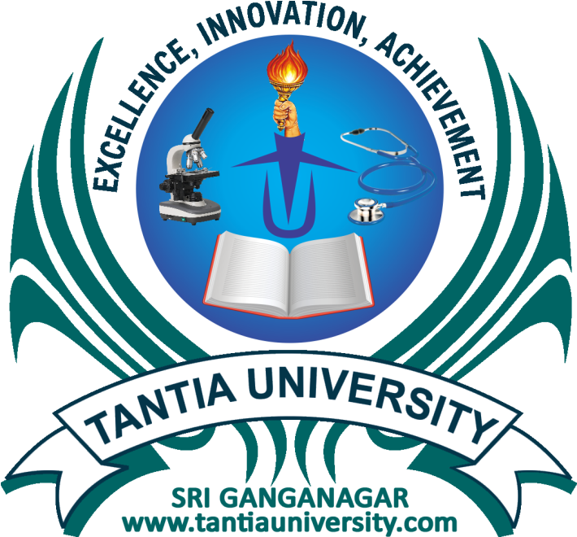

ORGANIZED BY
FACULTY OF LAW,
TANTIA UNIVERSITY
SRI GANGANAGAR (RAJASTHAN)

ABOUT THE INSTITUTION
Tantia University, Sri Ganganagar was established vide Act No. 32 of 2013 of the Rajasthan State Legislative Assembly with the assent of Hon’ble Governor of Rajasthan on September 16, 2013. It aimed at providing quality education to the masses of this border area, deprived of resources, at a nominal cost.
It gives pleasure to place on record that over this short period the University has succeeded in achieving its primary goal. Today, it has a huge infrastructure spread over 45 acres of land. It has 14 fully developed Colleges/Faculties viz. Ayurveda, Homoeopathy, Pharmacy, Allied Health Sciences, Nursing, Agriculture, Law, Education, Physical Education, Engineering, Commerce & Management, Science, Arts and Craft, Veterinary Science. A Medical College and a Veterinary College are on top planning and are likely to be established soon. Further, a 300 bedded Jan Sewa Hospital with all modern amenities has already been developed and running for the last two years. All laboratories have state of the art infrastructure, smart classrooms and libraries are well stocked. Above all, it is all supported by a dedicated team of staff and academicians.
ABOUT THE NATIONAL SEMINAR
The history of legislative operation in India started with the Indian Penal Code, 1860. Section 268 defined that what is Public Nuisance. Abetment of Public Nuisance is also a subject of Sections 133 to 144 of CrPC, which are only prohibitive provisions. Sections 269 to 278 of IPC are Penal provisions dealing with different aspects of public safety, tranquility.
Legislative efforts for control of Pollution continued in Independent India. Presently there is a plethora and public order legislation in India aimed at protecting the Environment from pollution and maintaining the ecological balance. The Environment Protection Act, 1986 is one major Act for environmental protection. The Government of India from time to time launched various programmes and made comprehensive use of media to educate people and raise their consciousness for the protection of environment.
In February 1971, the University Grants Commission (India), in collaboration with other organizations, hold a symposium on the development of Environmental Studies in the Indian Universities. The consensus that emerged at the symposium was that ecology and environmental issues should form part of the courses of study at all levels.
The first and foremost course for environmental protection is educating the people on the subject and creating awareness. However, due to negligence and preferential treatment to the economic gains of the society, industry causes great damage to the environment in the process of meeting the desired needs. The situation can only be controlled by enacting and enforcing the legal provisions. The present National Seminar is aimed to discuss at length about the legitimacy of preventive, protective and precautionary steps towards environment conservation.
SUB THEMES OF THE SEMINAR:
- Legislative Initiative to Protect Environment
- Status of Environment Protection
- Socio-Economic & Legal Aspects to Protect Environment
- Political Aspects to Protect Environment
- Other themes related to Environmental Protection

GUIDELINES FOR SUBMISSION:
Interested participants should submit an abstract of their original research/conceptual paper and empirical studies/case briefly describing objectives, methodology, major results and its implications in about 250 to 500 words. All abstracts will be peer reviewed and evaluated before final acceptance. Authors of accepted abstracts will be invited to submit and present full paper at the seminar. Accepted abstracts are likely to be published in the souvenir of the Seminar. The length of the paper should normally not exceed about 4500 words (excluding tables, figures, illustrations, references ) and it must be typed in Times New Roman font size 12 on A4 size paper with 1’’margin on all sides with 1.5 line spacing using MS Word. All the abstracts and full length papers shall be sent as an attachment on email id: dean.fol@tantiauniversity.com .
REGISTRATION PROCEDURE AND FEES
Participants willing to attend the seminar should fill the enclosed Registration Form and submit along with requisite fee. Filled- in registration forms can be sent electronically or by post. In case of electronic submission of registration form, requisite fee should reach Tantia University, Sri Ganganagar (Rajasthan) - 335002. Registration fee should be submitted through Demand Draft/Banker’s Cheque drawn in the favor of TANTIA UNIVERSITY or may be directly deposited to our account No. 00701131004560, ORIENTAL BANK OF COMMERCE, TANTIA UNIVERSITY RIICO Branch, Sri Ganganagar having IFSC Code ORBC0102015. The application form and fees can also be submitted on University’s Website www.fol.tantiauniversity.com.
Types of Delegates |  |  | Registration Fee
Academicians |  |  | ` 950
Professionals/NGO members/Policymakers |  |  | ` 950
PG Student/Research Scholars |  |  | ` 750
UG Students |  |  | ` 550
 | IMPORTANT DATES
 | Last date for sending abstract | 08th February, 2020
 | Acceptance of abstract | 14th February, 2020
 | Last date for sending full paper | 20th February, 2020
 | Date of Seminar | 22nd -23rd February, 2020

TRAVEL AND ACCOMMODATION
The participants are requested to make their own travel and lodging arrangements. However, for any assistance participants can contact organizing committee.
ABOUT SRI GANGANAGAR
Sri Ganganagar is a planned city and the northern-most city of the State of Rajasthan, Sharing borders of Haryana, Punjab and the international border of India and Pakistan. It is named after Maharaja Shri Ganga Singh Bahadur, Maharaja of Bikaner. It is known as ‘‘The Food Basket of Rajasthan’’ and as the city of Farmers.
CLIMATE
The climate of Sri Ganganagar varies to extreme limits. Summer temperature reaches 50⁰C and winter temperature dips just around 0⁰C. The average annual rainfall is only 200mm (7.9 in). During February the temperature is moderately cold requiring light woolens.
HOW TO REACH SRI GANGANAGAR
The nearest International Airport is at Bikaner (Nal) connected by road through the distance of 250 km. Sri Ganganagar has its own Railway station which is well connected to all the major cities of Rajasthan and other cities like Chandigarh, Delhi and Ahmedabad. The major trains running from Sri Ganganagar are Intercity Express, Hw Sgnr Express, Klk BME Express, Ned Sgnr Express, Delhi Sarai Rohilla Express, Sgnr Kota Express, Sgnr Mumbai Express, Ambala Intercity Express.
Tantia University, Sri Ganganagar is very well connected to various major cities by road. It is 50 km from Abohar, 50 km from Hanumangarh, 120 km from Bathinda, 160 km from Sirsa, 150 km from Ferozepur, 250 km from Hisar, 410 km from Delhi, 470 km from Jaipur and 500 km from Jodhpur, 245 km from Bikaner. Private and State Roadways buses run on these routes frequently.

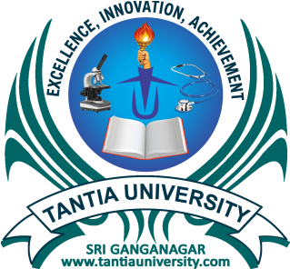
TANTIA UNIVERSITY
SRI GANGANAGAR

National Seminar
On
Environmental Protection: Constitutional, Legal & Regulatory Measures
22nd – 23rd February, 2020
Registration Form
(Kindly fill the form in Capital Letters)

Name……………………………………….……….. Designation…………………………………………………..

Organization (with complete address)…………………..………………………………………………………….

………………………………………………………………...…………………………………………….……………………….
Address for Correspondence………………………………………………………..…………………………………
………………………………………………………………………………………………………………….……………………
……………………...………………………State…………………………………..Pin Code………………………………
Mobile No. …………………….………… E-mail……….………………………..………………………………………...
Accommodation Required: - Yes ( ) No ( )
Title of Paper……………………………………..……………………………………..……………………………………
……………………………………………………………..………………………………………………………………………..

Mode of Presentation (tick one) 1. Oral 2. PPT

Payment Details

- Cash
- Cheque/ DDNo ………………………….……………. Date………….…………………….…………………
- Bank Transfer: Bank’s IFSC……………………….Branch………………………………………...…….
Date of Transfer……………………………….…….....

Signature of Participant
PATRON- IN- CHIEF

MRS. SUNITA TANTIA
(Chairperson, Tantia University)

PATRONS

DR. VISHU TANTIA
(Trustee)

DR. MOHIT TANTIA
(Vice-Chairperson, Tantia University)

PROF. M.M.SAXENA
(President, Tantia University)

ADVISORY COMMITTEE

MR. K.S. SUKHDEV
(Executive Director, Tantia University)

DR. ASHWINI GOGIA
(Director General Administration, Tantia University)

DR. PARVEEN SHARMA
(Director Research & Academic, Tantia University)

CONVENER

DR. SAURABH GARG
(Dean, Faculty of Law)

ORGANIZING SECRETARIES

MRS. SANDEEP KAUR MS. VIJAY KANWAR
(80940-78439) (70142-49647)

ORGANIZING COMMITTEE

DR. VINOD KUMAR SHARMA DR. RAJENDER KUMAR MR. RAJENDER SINGH
MR. GURJEET SINGH RATTA MRS. MEHAK RANI MR. SUDESH KUMAR
DR. KAPTAN CHAND DR. SUNITA BHADOO DR. RITU CHOUDHARY
MRS. SVEEN DHALL MR. RAM KUMAR DR. NARENDER DHAKA

For more information contact:
TANTIA UNIVERSITY
NEAR RIICO BUS STAND,
SRI GANGANAGAR (RAJASTHAN)-335002
Contact: – 0154- 2494123, 94140-93086
Email- dean.fol@tantiauniversity.com,
registrar@tantiauniversity.com
www.tantiauniversity.com

