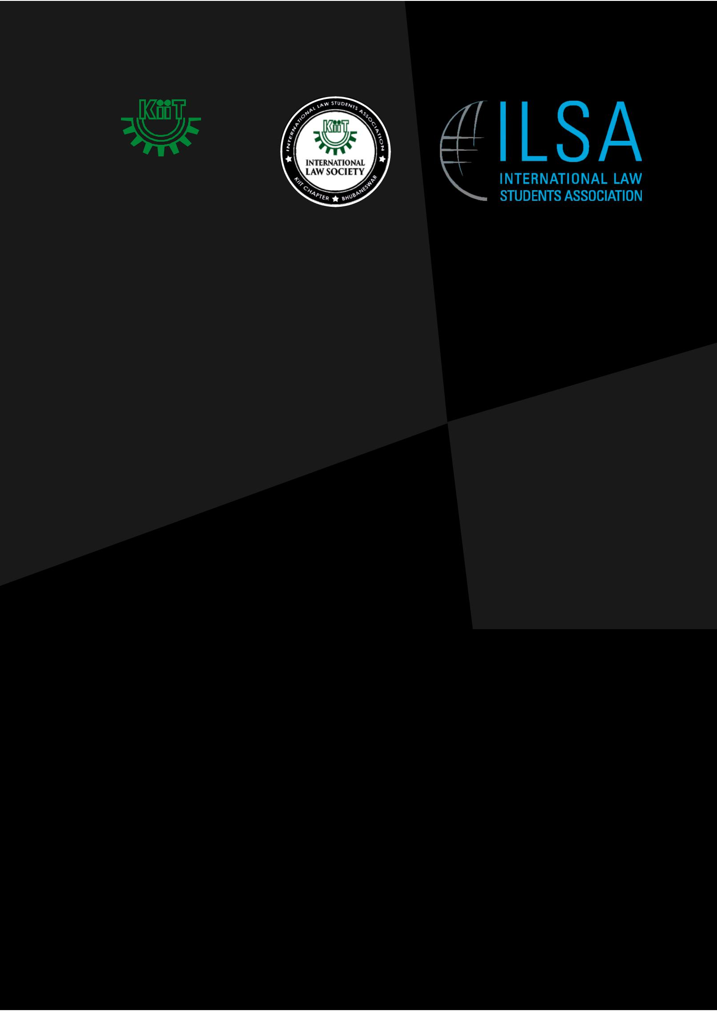

5th KIIT NATIONAL
CONFERENCE ON INTERNATIONAL LAW

6th March to 8th March, 2020

Organised by

INTERNATIONAL LAW SOCIETY

KIIT SCHOOL OF LAW, KIIT
DEEMED TO BE UNIVERSITY
BHUBANESWAR, INDIA



THE 5th KIIT NATIONAL CONFERENCE ON

INTERNATIONAL LAW

(6th MARCH- 8th MARCH, 2020)

ORGANISED BY:
INTERNATIONAL LAW SOCIETY
KIIT SCHOOL OF LAW,
KIIT DEEMED TO BE UNIVERSITY
BHUBANESWAR, INDIA

Table of Contents

ABOUT KIIT UNIVERSITY 2
ABOUT KISS UNIVERSITY 2
SCHOOL OF LAW, KIIT UNIVERSITY 3
INTERNATIONAL LAW STUDENTS ASSOCIATION 4
INTERNATIONAL LAW SOCIETY, ILSA CHAPTER 4
BACKGROUND 5
DIRECTOR’S MESSAGE 6
ABOUT THE CONFERENCE [12TH– 14TH] JAN, 2018 7
OBJECTIVES 7
SYMPOSIUM ON INTERNATIONAL LAW 8
THEMES FOR THE SYMPOSIUM/SEMINAR: 8
GUIDELINES FOR THE SYMPOSIUM 8
STRUCTURE OF THE ABSTRACT 9
STRUCTURE OF THE FINAL PAPER 9
DEADLINES: 10
TREATY NEGOTIATION COMPETITION 11
SUBMISSION GUIDELINES FOR TREATY 12
THEME FOR THE WRITE-UP 12
GENERAL GUIDELINES: 13
REGISTRATION 13
ACCOMMODATION, FOOD AND TRANSPORT 13
TIMELINE OF THE CONFERENCE 14
DEADLINES 15
AWARDS 16
MODE OF PAYMENT: 17
REGISTRATION DETAILS 18
ORGANIZING COMMITTEE 19
STUDENT COMMITTEE: 19
REGISTRATION FORM 20

ABOUT KIIT

KIIT deemed to be University (hereafter referred as “KIIT”) is situated in Bhubaneswar, capital of Odisha, and is one of the premier self-financing universities of the country. It caters to more than 20000 students from all across the nation and 22 other countries through more than 100 academic programmes like Law, MBA, Engineering, Bio-Technology, Rural Management etc., in more than 28 constituent campuses involving more than 1800 academic and research staff. The University has been accorded ‘Category A status’ by the Ministry of HRD, Govt. of India, and is accredited as ‘A’

Grade by NAAC and Tier 1 accreditation as per Washington Accord for Engineering streams by NBA of AICTE. The University has alliance with over 105 globally reputed foreign institutions, and had achieved the 16thposition among all national level universities, and 5th position among all national level Self-financing Universities, more details of which are available at www.kiit.ac.in.

ABOUT KISS

Started with just 125 students way back in 1993 by eminent educational and social entrepreneur Dr. Achyuta Samanta, Kalinga Institute of Social Science (KISS), Bhubaneswar has today grown into the largest free Residential Tribal Institute of the world. KISS provides food, accommodation, health care and all other basic necessities of life to 27,000 tribal children of the poorest of the poor background absolutely free to pursue education from Kindergarten to Post Graduation (K.G. to P.G.). Students are enrolled from 62 tribes of Odisha, including 13 Primitive Tribes.

The course curriculum designed for KISS is unique, for it incorporates vocational training with formal education, thus making a child educated and self-sufficient. Achievements of KISS students in examinations and other academic events speak volumes about the high quality of education at the institute. KISS students have been achieving cent percent pass record in annual examination for 7th, 10th and 12th Standards (Arts, Science and Commerce) for consecutive ten years. Students of KISS have been representing the State in prestigious National Children’s Science Congress every year since 2005. They have not only been qualifying in reputed institutions like NITs and IITs on the basis of their own merit, but have also been selected by top corporate names like Accenture, TCS and Wipro in campus placement. Students of KISS have proved their mettle not only in academics, but also in sports and cultural activities. Highpoints of these achievements have been their becoming Champion in Under 13 International Rugby Tournament held in Manchester, U.K. (19th June 2011) and participation of KISS students in Asian Games at Guangzhou (China) and Commonwealth Games (New Delhi). More details are available at www.kiss.ac.in.

KISS is the finest expression of KIIT’s social commitment. It plans to educate 2,00,000 tribal children during the next decade.

KIIT SCHOOL OF LAW

The School of Law, an integrated part of KIIT University, was established in the year 2007, and since then, we have consistently grown in stature and strength, and today we cater to a talent pool of over 1100 students from all across the country. We are one of the few law schools in India to provide conjoint degrees in the form of BA.LLB/BBA.LLB/BSc.LLB, and one of the very few Law schools providing for separate honors specializations involving eight separate papers each in International Law, Intellectual Property Law, Business Law, Constitutional Law, Crime and Criminology, and Taxation Law. The School of Law, is also a member of the International Association of Law Schools, Washington, U.S.A and Asia -Pacific Association of Law Schools, Australia. Further details are available at www.kls.ac.in.

INTERNATIONAL LAW STUDENTS ASSOCIATION

The International Law Students Association (ILSA) is a non-profit association of students and lawyers who are dedicated to the promotion of international law. ILSA provides students with opportunities to study, research, and network in the international legal arena. The organization's activities include academic conferences, publications, the global coordination of student organizations, and the administration of the Philip C. Jessup International Law Moot Court Competition. As an organization, ILSA seeks to promote awareness, study, and understanding of international law and related issues, encourage communication and cooperation among law student and lawyers internationally; contribute to legal education; increase opportunities for students to learn about other cultures and legal system worldwide and publicize educational and career opportunities in international law. ILSA serves as an umbrella organization for its member chapters (commonly known as International Law Societies) at individual law schools. This structure allows chapters to meet the unique needs of its members while still maintaining access to an international network of pooled academic and organizational resources.

INTERNATIONAL LAW SOCIETY, ILSA CHAPTER
The International Law Society at School of Law, KIIT University was established on the 23rd of July, 2009 in the interests of better legal education and higher standards of legal research and professional training and the development of International Law. Being a registered chapter of ILSA, the basic mandate of the Society is to prepare conscientious and competent legal professionals; the chapter, in addition, aims to develop among the students a sense of responsibility by developing socially relevant skills and approaches, and for developing better understanding of International Law and co-operation among students, academicians, organizations and educational institutes in the country and around the world, especially within the ILSA network. This student-run organization conducts regular sessions for its members and students on international legal concepts and contemporary matter.

BACKGROUND
The International Law Society at School of Law, KIIT University had organized the 1st KIIT National Conference on International Law during 15th-17th January, 2016.

The Conference was a part of ILSA Chapter Grants Program and hosted 3 events: Symposium
on International Law: Contemporary Issues and Challenges, Treaty Negotiation Competition and the 1st All India ILSA Chapters’ Meet.

The Symposium observed paper presentations from different areas of Public as well Private International Law. Second day of the conference observed The Treaty Negotiation Competition which was a one-of-its-kind competition wherein participants acted as representatives of different nations and re-negotiated a modified version of the Treaty of Versailles. We also took the novel initiative of inviting representatives from different registered chapters of ILSA all over the country for the 3rd event of the Conference, All India ILSA Chapters’ Meet. A total of 80 individuals from all across the country participated in the Conference including many professionals. Thus, the success of the first, subsequently ILSA organized the Second edition of the conference where during 13th - 15th January, 2017.The Conference was a part of ILSA Chapter Grants Program and hosted 3 events: Symposium on International Law: Contemporary Issues and Challenges, Treaty Negotiation Competition and the Essay Writing Competition. The Third Edition of the conference was held in January, 2018 which followed the same format as the previous years with more emphasis being placed on the Treaty Negotiation Competition. This edition saw even more increased participation from various law schools across the country. The Fourth Edition of the conference was held in 2019. Albeit the format was kept the same, the Treaty Negotiation Competition was slightly modified much to the acceptance of the participants. The Fourth Edition saw close to 90 participants for both paper presentations and treaty negotiation competitions. Thus, in light of success of the previous editions of the conference the ILSA chapter of School of Law, KIIT University is proud to announce that it is organizing THE FIFTH EDITION OF KIIT NATIONAL CONFERENCE ON INTERNATIONAL LAW & TREATY NEGOTIATION COMPETITION during the Academic session 2019-20.

DIRECTOR’S MESSAGE

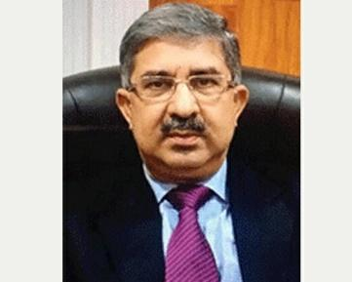
I am pleased to write this brief note regarding International Law Society of KIIT SCHOOL OF LAW.
The School of Law of KIIT Deemed to be University is a school of excellence imparting legal education for the last 12 years. The school caters to the needs of students all over India in general and in eastern region particularly. The school believes in dissemination of legal education not only through class room teaching but by other technics, including Workshops, Seminars, Moot Courts, Debates and Mock Trial etc. For this purpose, the School of Law has created a good number of centres which deal with different subjects. International Law Society is one such attempt in that direction. The society is a chapter of International Law Students Associations (ILSA). It was formed in 2009 and since then has done numbers of such events which promoted the awareness and knowledge about International Law.
The society has been doing excellent work in promoting, preserving and disseminating of knowledge during last decades. This year too, the society intends to have a conference of International Law on very important topics which are the global concern. I am sure that the society will do it graciously and meticulously. I wish all the best for the upcoming programme of the society.

PROF. (Dr.) S.C. RAINA
DIRECTOR,
KIIT SCHOOL OF LAW, KIIT

ABOUT THE CONFERENCE [6TH - 8TH] MARCH, 2020

International Law defines the legal responsibilities of States in their conduct with each other, and their treatment of individuals within State boundaries. Its domain encompasses a wide range of issues of international concern such as human rights, disarmament, international crime, refugees, migration, problems of nationality, treatment of prisoners, the use of force, and the conduct of war, among others. It also regulates the global commons, such as the environment, sustainable development, international waters, outer space, global communications and world trade. The International Law Society at School of Law, KIIT University is organizing the 5th KIIT National Conference on International Law to provide the young generation with a platform where they can deliberate upon the theoretical as well as practical aspects of International Law. Being an extended organ of ILSA, the Conference is being organized as a part of ILSA Chapter Grants Program. The conference aims to give a platform for interaction between the students and practitioners and academicians who possess vast knowledge in the areas so identified in the themes.

OBJECTIVES

The objective of the conference is to provide a platform to students of various law schools where they may hone their skills of negotiation and diplomacy. Through this we hope to generate interest not only in international events that take place in the world but also develop greater awareness about international relations and its ever-changing nature. It will also give the students of KIIT University a chance to meet and interact with students of other law schools, legal luminaries, etc. while also getting an opportunity to observe the intricacies and nuances of diplomatic negotiations on an international scale.

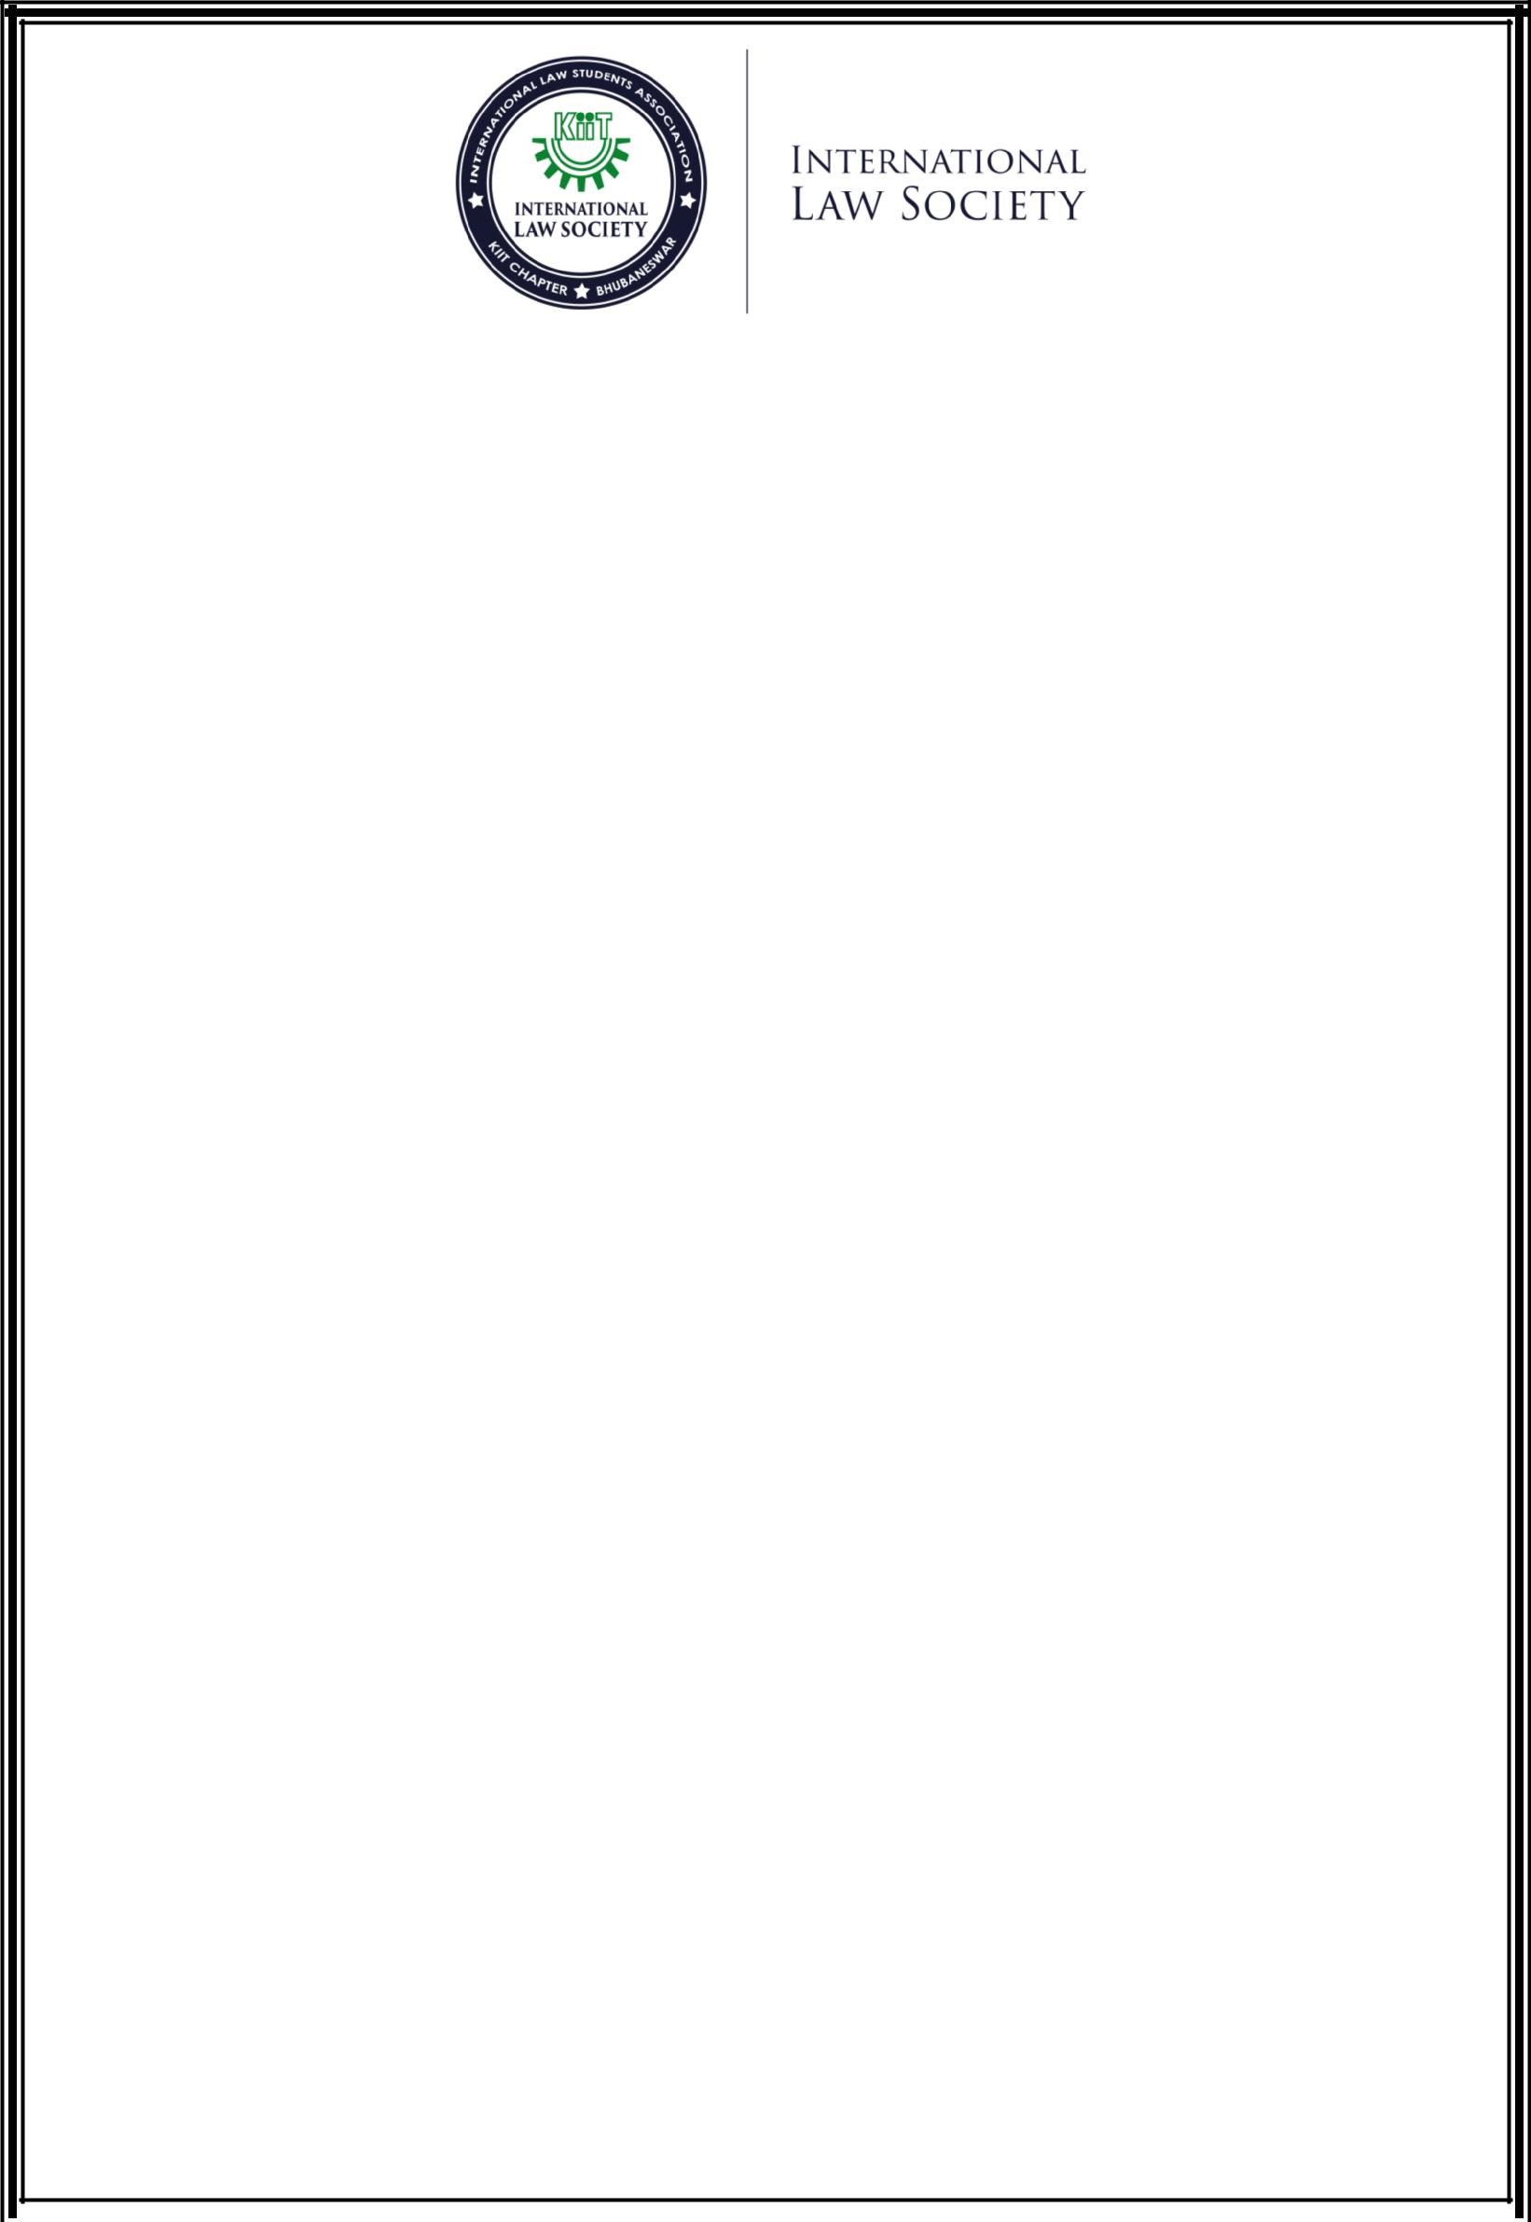

SYMPOSIUM ON INTERNATIONAL LAW

The International Law Society will host a Symposium on International Law - Contemporary Issues and Challenges during the Conference. The objective of this Symposium is to foster the interest and explore the contemporary areas in International law. The following areas of law have been decided upon to be discussed in the SYMPOSIUM

THEMES FOR THE SYMPOSIUM/SEMINAR
- Trade, Development and Human Rights.
- Impact of climate change and International Human Rights
- Application of International Law in Cyberspace

The School of Law, KIIT University calls for research papers from undergraduate/post-graduate students and invites them to present their papers during the Symposium.

GUIDELINES FOR THE SYMPOSIUM

- All papers should be sent via email to kiitilsaconference2020@gmail.com in.doc or .docx format.
- The body of the manuscript should be in Times New Roman, size 12 in 1.5 spacing, 1 inch margin on all sides. The footnotes should be in Times New Roman, size 10 in single spacing.
- A uniform system of citation style should be followed.
- Author(s) have to send an abstract of the Paper within 300 words. Names, affiliated college, email id and contact number of the author (s) to be furnished at the end of the Abstract.
- The length of the Paper should not exceed the limit of 6000 words. Inclusive of footnotes. Authors are requested to stick to the word limit. Violation of this rule will attract deduction of marks.
- Co-authorship of maximum two authors per Paper is allowed.
- The author(s) will send a separate Cover Letter with their final papers incorporating details like name(s), affiliated college, full postal address, email id and contact number along with the title of the Paper. The Paper should not contain any biographical references of the author (s).
- All Papers must be an original work of the author(s). Plagiarism will lead to cancellation of the Paper.

STRUCTURE OF THE ABSTRACT

- Title: Font – Times New Roman; Size – 18; Line Spacing – 1.5; Alignment – Centre; Uppercase; Bold face
- Body: Font – Times New Roman; Size – 12; Line Spacing – 1.5; Alignment – Justified; Margins – 1 inch on all sides;
- Details of the Author(s): Names, affiliated college, email id and contact number to be furnished at the end of the Abstract;

STRUCTURE OF THE FINAL PAPER

- The first page of the Final Paper must be the Abstract without the contact details of the author(s).
- The length of the Paper should not exceed the limit of 6000 words (inclusive of footnotes).
- Authors are to stick to the word limit. Violation of this rule will attract deduction of marks.
- All the pages of the Final Paper will have Margin of 1 inch on all sides;
- Main Title of the Paper: Font – Times New Roman; Size – 18; Line Spacing – 1.5; Alignment – Centre; Uppercase; Bold face
- Body: Font – Times New Roman; Size – 12; Line Spacing – 1.5; Alignment – Justified;

DEADLINES:

- Last date for abstract submission for Symposium: 31st of January, 2020;

- Notification of selected abstracts: 9th February, 2020;

- Last date for submission of final papers of selected abstracts: 23rd February, 2020.

TREATY NEGOTIATION COMPETITION

Treaties are a serious legal undertaking in international law. Once in force, treaties are legally binding on the parties and become part of international law. Their importance as a source of international law is ever increasing. The law on treaty-making process is governed by the Vienna Convention on Law of Treaties whose preamble clearly stipulates that codification of treaties promote the development of friendly relations among nations along with international peace and security.

The Treaty Negotiation Competition aims to spread awareness about the importance of the treaty-making process among the participants and encourage development of the Art of Diplomacy and Statesmanship. Unlike a Court’s order which is a win or lose situation for either of the parties, treaty negotiation is a process which is a win-win situation for all the participating nations. The Competition will help in honing the negotiation skills of the participants at international level given the fact that they will be representing a nation on the table.
The format of the Treaty Negotiation Competition is based on the workings of various bodies and agencies of United Nations as well as other independent organizations which cater to the treaty negotiation process in various global spheres. Participants will be given a general background and the clauses which will contain the issues that are to be deliberated upon in the oral rounds. The participants will first send in their written submission in the form of Framework Agreements.

They will then carefully consider each other’s contention in the oral rounds and will try to negotiate and reach to a consensus on all the issues. The key objective of this Competition is to inculcate in participants the sense of innovation along with negotiation skills which are essential in a lawyer.

The theme of the competition revolves around “CLIMATE CHANGE AND PROTECTION OF REFUGEES ”.

- Teams will be allotted specific countries
- Teams are required to prepare framework agreements for their respective countries (Rules and other details will be provided upon selection of teams)
- Teams [comprising of 2 students] will be allowed to discuss on their proposed submissions during the oral rounds.

SUBMISSION GUIDELINES FOR TREATY

For the Treaty Negotiation Competition, interested participants are to submit a write-up within a word limit of 1500 words (inclusive of footnotes). On the basis of the write-up further selections will be made for allotment of Countries which the teams are to represent in the 'Oral Rounds'. It is to be noted that this write-up is only for the purpose of selection/scrutiny of the teams for the Treaty Negotiation competition. It shall not be considered for the final evaluation of the aforementioned competition. The background of the treaty and the rules for the same shall be provided later following selection. Clarifications (max. 3 per team) regarding the facts of the Treaty are to be communicated through mail. Your registration will be deemed to be completed only after submission of the soft copy of the demand draft.

- Last date for submission of TNC registration (along with write-up): 5th February, 2020

- Notification of selected teams for TNC: 8th February, 2020 (23:00 hours)

- Last date for Framework Agreement submission for TNC: 1st March, 2020

THEME FOR THE WRITE-UP
Interested Candidates are to submit their write-up on Protection of Refugees under International Law.

GENERAL GUIDELINES:

REGISTRATION
- The students shall be formally registered as a participant for the Conference only after the receipt of the Demand Draft. A confirmatory email will be then sent to such participants.

- The participants have to send a soft copy of their itinerary to kiitilsaconference2020@gmail.com by 3rd March, 2020.
- FINALITY OF DECISION – The decision of the judges and panel with regard to the outcome of different events of the Conference shall be final. For all purpose and in any dispute, the decision of the Organizing Committee of the Conference shall be final and binding.

ACCOMMODATION, FOOD AND TRANSPORT

- Interested Participants can avail the facilities of accommodation along with food by paying an additional amount of Rs. 1000/- (Rupees One Thousand only).
- Accommodation will be provided from 5th March, 2020 (evening) to 9th March, 2020 (morning).

- The participants will be provided transport facilities for pick-up from the airport/railway station to the University premise and from their place of accommodation (if availed) to the Conference venue throughout the Conference. The participants must make their own arrangements for their departure from the University premise after the Conference is over.

TIMELINE OF THE CONFERENCE

DAY | TIMINGS | EVENT
DAY 1 | MORNING SESSION  AFTERNOON SESSION | REGISTRATION FOR THE EVENT  INNAUGURAL CEREMONY
DAY 2 | MORNING SESSION  AFTERNOON SESSION  EVENING | PAPER PRESENTATION ON IMPACT OF CLIMATE CHANGE AND INTERNATIONAL HUMAN RIGHTS.  PHASE 1 (TREATY NEGOTIATION COMPETITION)  PHASE 2 (TREATY NEGOTIATION COMPETITION)  DINNER BY DIRECTOR
DAY 3 | MORNING SESSION  AFTERNOON SESSION | PAPER PRESENTATION ON APPLICATION OF INTERNATIONAL LAW IN CYBERSPACE.  FINAL PHASE OF TREATY NEGOTIATION COMPETITION  CLOSING CEREMONY

DEADLINES

- Last date for submission of TNC- 5th February, 2020

- Notification of selected teams for TNC: 8th February, 2020 (23:00 hours)

- Last date for abstract submission for Symposium: 6th February, 2020

- Notification of selected abstracts: 9th February, 2020

- Last date for registration and payment: 15th February, 2020

- Last date for receiving of hard copy of the Demand Draft: 20th February, 2020

- Last date for submission of final papers of selected abstracts: 23rd February, 2020

- Last date for Framework Agreement submission for TNC: 1st March, 2020

AWARDS

- Winner of Treaty Negotiation Competition – Rs. 20,000
- Best Framework Agreement- Rs. 10,000
- Best Paper- Rs. 10,000
- 2nd Best Paper- Rs. 5,000
- Best Presenter- Rs. 5,000

Note: Plagiarism more than 20% won’t be published.

REGISTRATION FEES

- Symposium: Rs. 1000/- (per person)
- Treaty Negotiation Competition: Rs. 1000/- (per person)
- Accommodation (including food): Rs. 1500/- (per person)

MODE OF PAYMENT:

All payments should be made in the form of a Demand Draft drawn in favor of “KIIT”, and

Payable at Bhubaneswar (stating the name of the participant and the institution at the reverse

Side of the demand draft), addressed to:

Ms. Mitul Dutta, Faculty Convenor, The 5th KIIT

National Conference on International Law, 2020, KIIT School of
Law, Patia Bhubaneswar, Odisha – 751024

- The Registration Fee is non-refundable and non-negotiable.

- Dress Code – The participants are expected to follow a strict dress code of western formals.

- Awards and Certificates – All the participants will receive a Participating Certificate for the Conference during the Valedictory Function. The prize winners for different events will receive a separate certificate commemorating their achievement along with the trophies, monetary prize and other benefits.

- The details of the Structure of Framework Agreements and the Oral Round of the Treaty Negotiation Competition will be conveyed upon final confirmation of participating teams.

- Guidelines of the Conference should be strictly adhered to. Any deviation thereof can attract penalties or disqualification.

REGISTRATION DETAILS

The students shall be formally registered as a participant for the Conference only after the receipt
of the Demand Draft. A confirmatory email will be then sent to such participants. The participants have to send a soft copy of their itinerary to kiitilsaconference2020@gmail.com by 3rd March, 2020.

The links for the registration forms have been given below. Participants please be advised that we are using Google forms for the purpose of our convenience. The interested participants can register themselves by filling up our Google forms. The link to the forms can be found at our blog at klsils.wordpress.com. The links are also accessible on Lawctopus.

- The Last date for registration and payment: 15th February, 2020.
- Last date for receiving of hard copy of the Demand Draft: 20th February, 2020.

ORGANIZING COMMITTEE

CHIEF PATRON:
Dr. Achyuta Samanta, Hon’ble Founder, KIIT & KISS
PATRONS:
Prof. Hrushikesh Mohanty, Vice Chancellor, KIIT
Prof. (Dr.) Subrata Kumar Acharya, Pro-Chancellor, KIIT
Prof. Sasmitarani Samanta, Pro-Vice Chancellor, KIIT

CHAIRMAN:
Prof. (Dr.) S.C. Raina, Director, School of Law, KIIT
FACULTY CONVENOR:
Ms. Mitul Dutta, Assistant Professor of Law

STUDENT COMMITTEE:

For queries related to the symposium please contact:

Anubrata Banerjee – +91 9830671192
Zeenat Ul Kubra -+91 8603174592

For queries related to the TNC, contact:

Pratyay Ghatak - +91 8637211403
Megha Maiti -+91 8240853060

For any other general queries, contact:

Ragini Chakraborty-+91 7044143305
Abhishek Maitra-+91 9685970886
Joyjit Sinha - +91 9434315437

REGISTRATION FORM

THE 5th KIIT NATIONAL CONFERENCE ON INTERNATIONAL LAW

6TH TO 8TH MARCH 2020

REGISTRATION FORM

(TO BE FILLED IN BLOCK LETTERS)

EVENT: SYMPOSIUM [ ] TREATY NEGOTIATION COMPETITION [ ]

1ST PARTICIPANT

NAME: ___________________________________________________________________________

NAME OF THE INSTITUTION: ______________________________________________________

ADDRESS: ________________________________________________________________________

CITY: ______________________STATE: _______________________ PIN CODE: _____________

CONTACT NO.: ___________________________________________________________________

E-MAIL: ___________________________________________@_____________________________

SIGNATURE: ____________________________

2ND PARTICIPANT

NAME: ___________________________________________________________________________

NAME OF THE INSTITUTION: ______________________________________________________

ADDRESS: ________________________________________________________________________

CITY: _____________________STATE: ________________________ PIN CODE: _____________

CONTACT NO.:____________________________________________________________________

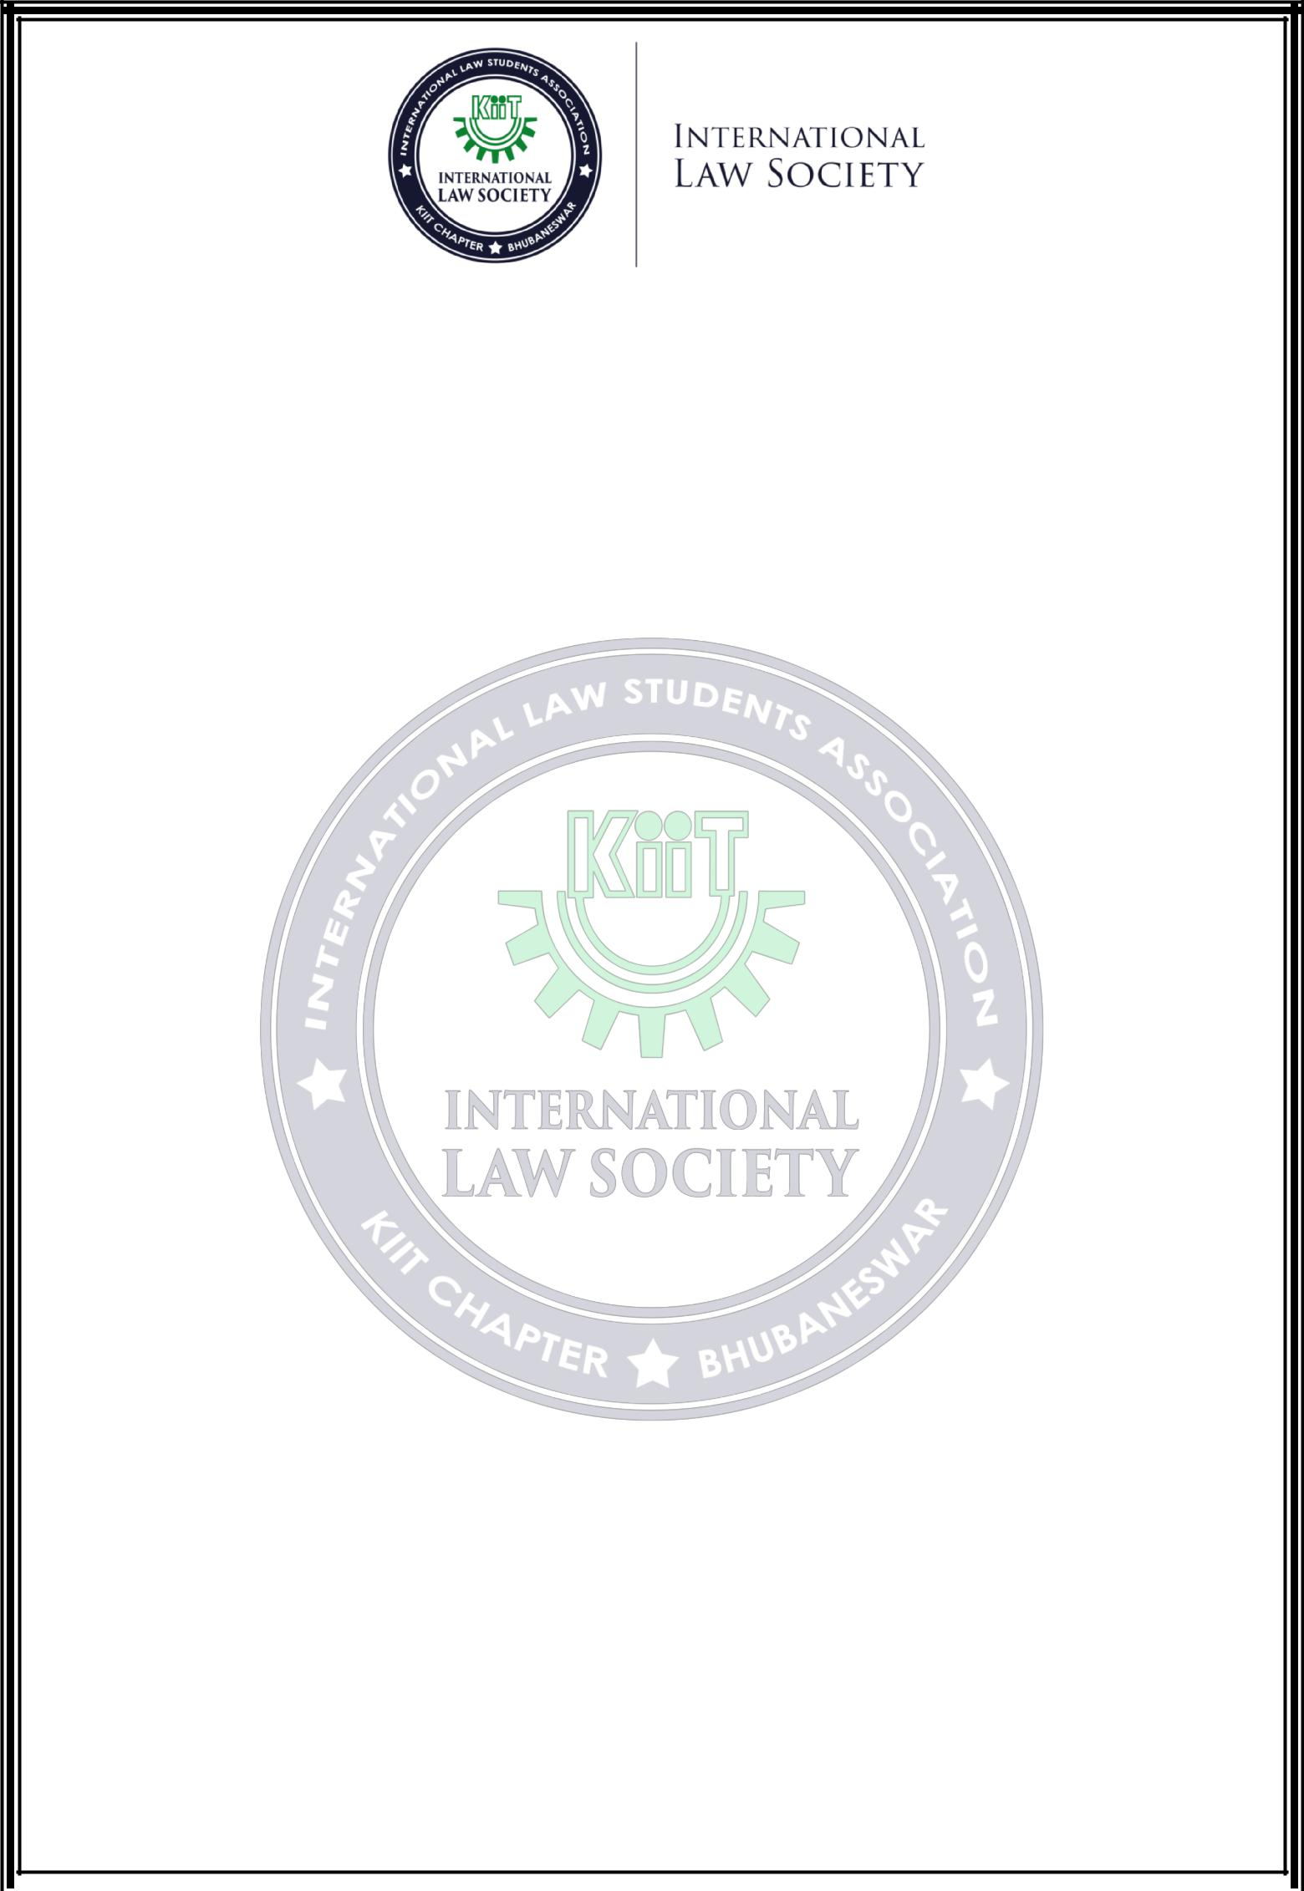
E-MAIL: ___________________________________________@_____________________________

SIGNATURE: ____________________________

THEME AND TITLE OF THE PAPER FOR SYMPOSIUM/COUNTRY FOR TREATY NEGOTIATION COMPETITION:

__________________________________________________________________________________

__________________________________________________________________________________

ACCOMMODATION: | [ ] YES | [ ] NO
DEMAND DRAFT DETAILS:
DEMAND DRAFT NO.: | _____________________________________________________
AMOUNT: | _____________________________________________________
DRAWN ON BANK: | _____________________________________________________
FAVOURING: | _____________________________________________________
DATE: | _____________________________________________________
ITINERARY:
DATE OF ARRIVAL: | ________________________________ TIME: ________________
DATE OF DEPARTURE: | ________________________________ TIME: ________________

NOTE – The Demand Draft should be drawn in favour of “KIIT” and payable at “BHUBANESWAR”. Please mention your name on the reverse side of the Demand Draft.

The original copy of the form should be sent by 21st February, 2020.

* The Registration Fees is non-refundable.

OUR PARTNERS

We extend our heartfelt gratitude to all our sponsors and partners who helped us inorganizing this conference with their invaluable support and contribution.

ORGANIZED BY

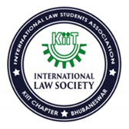
TITLESPONSOR
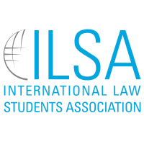

5thKIIT NATIONAL
CONFERENCE ON INTERNATIONAL LAW
