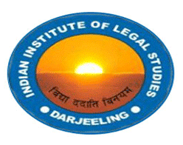
@
"Infringement of Trademark in India:
Emerging Issues and Challenges".
National Seminar on:

Organized by:
Indian Institute of Legal Studies
Accredited by NAAC
Affiliated to the University of North Bengal
Recognized by the BAR COUNCIL OF INDIA, New Delhi
Approved under Section 2(f) & 12(B) of the UGC ACT, 1956

Venue: Conference Hall
Indian Institute of Legal Studies
Siliguri, P.O. Salbari, Dist- Darjeeling, west Bengal, India Pin- 734003
Phone: +91-353-2574013/2574697, fax: +91-3532574698
Website- www.iilsindia.com

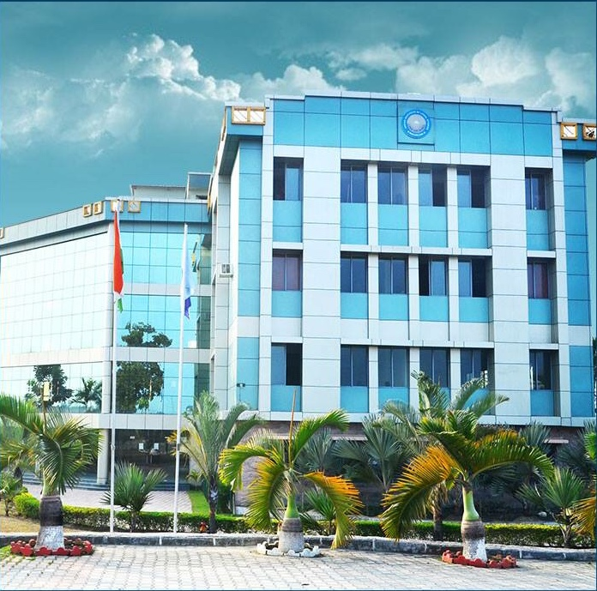
About the Institute
The Indian institute of legal studies was established in the year 2010 under the aegis of the Bar Council of India (BCI), New Delhi and the University Grants Commission (UGC). The Institution has successfully and positively caught the fancy of various students and law experts from all over the nation. The primary purpose of Indian institute of legal studies (IILS) has been to ensure an ideal dissemination of excellent academic opportunities for legal education. The possibility for providing an access to such a basic yet crucial educational platform for the betterment of the society in general has been due to the vision and endless determination of Shri Joyjit Choudhary, Hon’ble Chairman, Indian institute of legal studies. A visionary who, believed to provide for every individual the right to proper and fair education, as their fundamental right, has been venturing with a superior fervor for enhanced academic prospects untiringly.
The institution is nestled in the foothills of the Himalayas, situated in the heart in Darjeeling District, Siliguri, and West Bengal. The institution’s vital location, its active participation in imparting knowledge and moulding its students into sensible and responsible individuals has brought to its credit to serve as the nucleus for education in the hills of North Bengal. The emphasis in the academic development with its adoption of inter-disciplinary and practical approach has aided its students to gain deeper understanding of the learning process and value for education. Additionally, it has not merely laid the importance for the value and the need to be educated individual, or to serve as efficient lawyers, but more essentially, to be reborn as a society viable, constructive and to construct appropriate mechanisms for building a better society for the coming future.
IMPORTANCE OF THE TRADEMARK LAW IN INDIA
Protection of trade mark rights has become very essential in certain countries like India.
The trade mark Registry recognizes well known trademarks in India on the basis of international, national and cross border reputation. The trademark act, 1999 protects the well-known trademark in two ways: an action against the registration of smiles marks and an action against the misuse of the well-known mark.

However along with the well-known proprietor it is also essential to protect the right of the small-scale proprietor also. Hence the main agenda of this national seminar would be to find out and discuss on the matters and issue of the large scale as well as small scale proprietors and the challenges they face in the contemporary time in context of India.

The growth in the awareness level shall be the utmost propaganda for us, so that we can help and find out the solutions for the upcoming challenges in near future.

Trademarks, copyrights and patents protect various types of intellectual properties, where trade mark is typically protects the brand names and logos used on goods and services.

Therefore, with facility, there comes a great responsibility to protect and maintain it. Thus, we should all make an oath for preserving and protecting the rights equally for all the communities and sectors in India.

SUBMISSION GUIDELINES:
About Registration:There is no charge for registering for the Seminar.
- The submission shall consist of an abstract.
- An Abstract shall not be more than 250 words excluding title and keywords.
- The length of the paper should be of 3000-5000 words.
- Full paper can be submitted on the day of Seminar.
- Footnotes must conform to the authoritative standard, rules of legal citation and must include a description of each authority adequate enough to be understood by a reader to identify and locate the authority in a publication of general circulation.
- Paper in MS Word format with the subject “IILS NATIONAL SEMINAR 2019”.
- The cover page must contain the name, nationality, e-mail, contact number, and the name of the College/University along with the address of the participants.
- In case of co authorship, the covering letter should include details of both the authors
- Submission of full paper must be made to iilssilliguri.lawdepartment@gmail.com
- Delegate must submit the hard copy of his/her paper on the day of the conference, at the registration desk.
- The paper should be in the following format:
Font Type: Times New Roman.
Font Size: 12 pt.
Line Spacing: 1.5
Foot Note Size: 10pt
Citation Format: Bluebook 20thEdition/ILI Citation Style.
- All the participants shall receive a certificate for presenting their paper in the seminar.
- With regards to any queries please contact the teacher coordinators.

IMPORTANT DATES
- Submission of Abstract: 6th December 2019
- Intimation of selected Abstract: 10th December, 2019.
- Full paper can be submitted on the day of Seminar
- Seminar Date: 16th December 2019

VENUE
Indian Institute of Legal Studies, Siliguri.

TEACHER COORDINATOR
Ms. Bandita Sengupta, Assistant Prof of Law, IILS, (+91 6296903440)
Ms. Deekshita Das, Assistant Prof of Law, IILS, (+91 7002748443)
Ms. Anuttama Ghose, Assistant Prof of Law, IILS, (+917894270847/ +91 6296903427)

