One Day National Symposium on
Water Harvesting and Water Conservation: Sustainable Utility
September 14, 2019
Organized by | 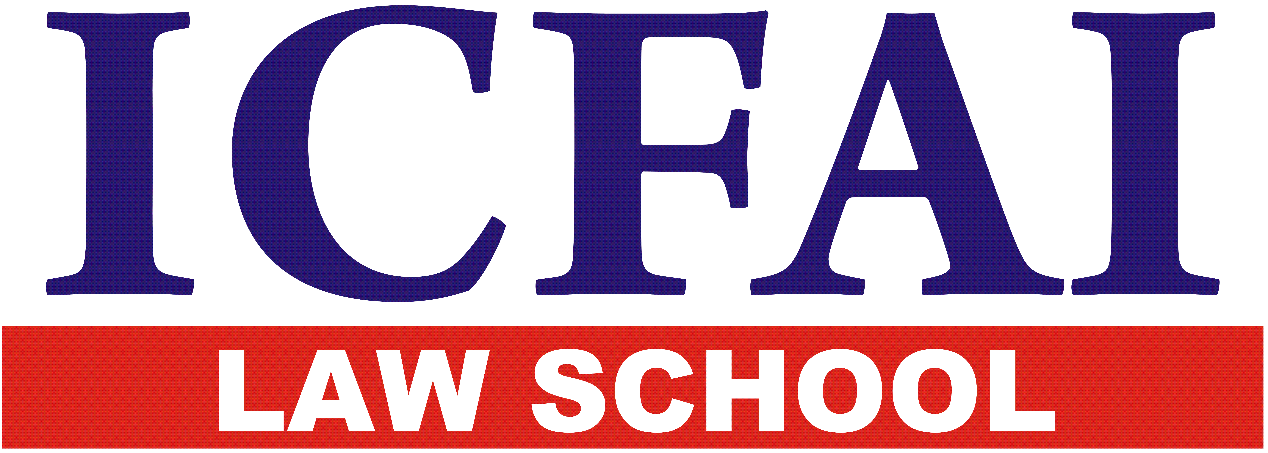 | ICFAI Law School  The ICFAI Foundation for Higher Education  (“Deemed University” under Section 3 of the UGC Act, 1956)

Registration Form
 | Name
 | Designation
 | Name of the Institution
 | Address for communication
 | E-mail
 | Mobile No.
 | Payment Mode: | Payment Mode: Amount
 |  | DD/ NEFT/ RTGS |  |  |  | No. |  |  |  | Date:
 |  | Bank
 |  | DD sent by post |  |  |  |  | DD submitting on Registration
 | Whether requires accommodation | Yes/No
 | If requires accommodation
 | - Date of arrival at campus
 | - Mode of Travel
 | - Days of Stay

Declaration
I, ___________________________________________________________hereby declare that the information given above is true and correct to my knowledge. I will abide by the rules of University during my stay in the Campus.

Date: Signature

