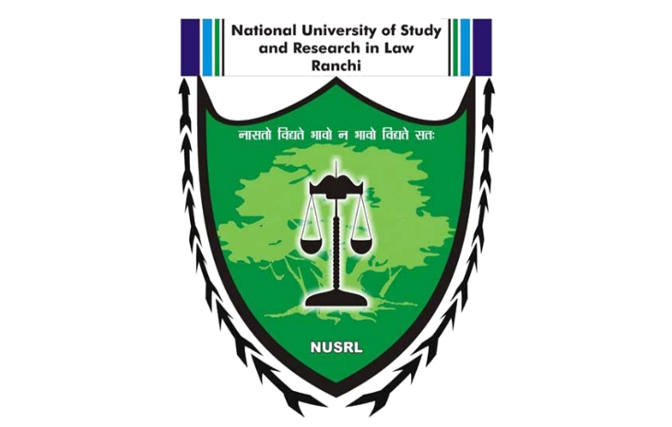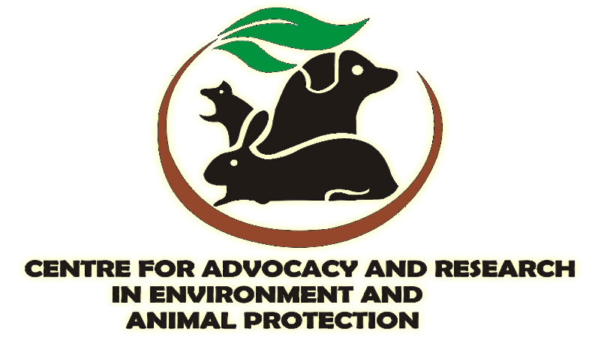

1st National Animal Law Essay Writing Competition, 2019
on
The Protection of Animal rights and Role of Judiciary

Organised by :
Centre forAdvocacy and Research in Environment and Animal Protection (CARE-AP),
of
National University of Study and Research in Law, Ranchi

- Reward :
Every successful submission will be awarded Certificate of Participation. Apart from these, few selected submissions will be appreciated by exciting rewards.
- The first Position will be rewarded with prize money of ₹ 3000 along with the Certificate.
- The second Position will be rewarded with prize money of ₹2000 along with the Certificate.
- The third Position will be rewarded with prize money of ₹1000 along with the Certificate.
Apart from these, the top ten essays will be published on the official blog of CARE-AP.

- Eligibility :
- The Competition is open for all the students currently pursuing their under-graduation (both 3year and 5year)course from any recognized university/college in India.
- Individual participation as well as participation up to two authors i.e. co-authorship is allowed for one entry. In the case of co-authorship, registration of both the authors is mandatory.
- There is no restriction on the number of entries from any college or university.
- The essays will be scored based on originality of analysis, depth of research, style of writing and communication of arguments. The decision of the evaluators will be final and binding.
- The copyright in the drafts submitted by the participants shall vest with the CARE-AP. Further, CARE-AP shall not be responsible for any liability accrued to any person or for any loss caused to any person because of the content of the draft submitted.
- A certificate of participation shall be e-mailed to all participants who have successfully submitted the essay.

- Important Dates:
Last date of registration | 25th May 2019
Last date of submission | 25th May 2019

- Theme of Competition:
The theme of the Competition is The Protection of Animal rights and Role of Judiciary. It may also include the following sub-themes:
1. Justifiability of Animal Rights.
2. Need for amendment of Laws with respect to Animal Rights.
3. Endangered Species and their Care: A Legal Study
4. India’s Obligation in respect of animal rights under international law.
5. Issues and Challenges faced by the govt. in Protection of Animal Rights.

- Formatting:
- The language of the Essay must be in English.
- The word limit is 3000 words (not including footnotes).
- The font used in all parts of the essay (except footnotes) must be Times New Roman, Size 12, with 1.5 line spacing with justified alignment.
- The font used in the footnotes must be Times New Roman, Size 10, with single line spacing with justified alignment.
- A uniform citation style has to be followed throughout the essay.
- Page numbers must be at the bottom center.

- Registration &Submission Guidelines:
- The registration and submission must be done simultaneously before 25th May 2019 by filling all the details required by clicking here.
- There is no registration fees.
- The electronic copies must be submitted in PDF format.
- The organizers are very particular about the plagiarism as it defeats the purpose of the Competition. Only original essays that have not been published elsewhere and have not been submitted to any other organization are to be submitted. Hence, the participants are advised to take care of the same.

- Queries and Clarification:
For any further information/ clarification, send mail on careap@nusrlranchi.ac.in or kindly contact the following person:
- Aditya Saurabh, Contact @8797379700
- Epil Bodra, Contact @7461068166

