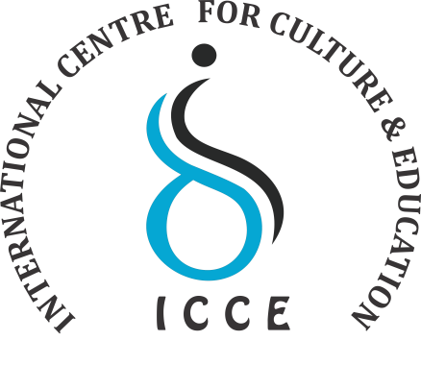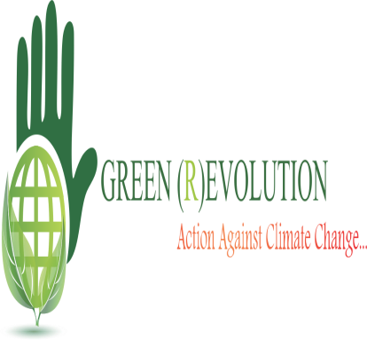

College Program/Public Program

- COLLEGE PROGRAM
Green (R) evaluation Global Certification program is an International level short term course study for college students- Undergraduates and Postgraduates-across all streams.
COLLEGE PROGRAM

Age Group | Above 16
Examination | Online
Schedule | June and July
Fees | 750/-
Accepted through | Climate counselor

Public Program

Green (R)evolution Global Certification Program is an International level short term course study for everyone above the age of 12.
Program Summary for Green (R) evolution Public Program.

PUBLIC PROGRAM

Age Group | Above 12
Examination | Online only
Schedule | June-July
Fees | 750/-
Accepted through | Earth Ambassador
Important Date

Last Date of Registration : 25th June
Confirmation Date : 26th June

*Interested candidate send their CV and why they want be the part of this program up to 250 words.
*E-mail ID: nikitakaushik3800@gmail.com .
*Selected candidate will have interview call.
* After Selection Mode of Payment will be given.
*For any queries Mail at: nikitakaushik3800@gmail.com or contact: 8685044469.
* Earth Ambassador: Nikita kaushik
* Coordinator: Ms. Dimple
