One Week National Workshop
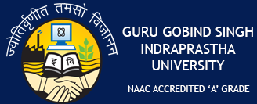
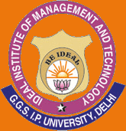
on
“Multi-Disciplinary Approach in Law and
Applicability of
Research in Management”

17th July-22nd July, 2017 (Monday to Saturday)

Registration Form Date:
S.No. | Details | To be filled by Participant
 | Area (Management/ Law/ Other)
 | Name (In CAPITAL)
 | Designation & Department
 | Institution Name
 | University (If Any)
 | Postal Address
 | Contact No. / Mobile No.
 | Email Id.
 | Mode of Payment | 1.Demand Draft  2. NEFT  3. Cash

Bank Money Transfer through NEFT:
BENEFICIARY NAME: IDEAL INSTITUTE OF MANAGEMENT AND TECHNOLOGY
ACCOUNT No. : 1021422987 ACCOUNT TYPE: SAVING ACCOUNT
BANK NAME : CENTRAL BANK OF INDIA IFSC CODE : CBIN0283323
BANK ADDRESS : S.D.SR. SEC. SCHOOL , SHAHDARA, DELHI 110032
NOTE: Receipt of online transaction should be attached with the Registration Form.
NEFT/ Online Transfer# Details:
Receipt No. : _______________________ Amount: ___________________
Dated : _______________________
OR
DD in favor of “Ideal Institute of Management & Technology”, payable at Delhi. Demand Draft Details:
DD No. :____________________ Amount: ___________________ Dated: _____________________
Issuing Bank: __________________________________________________________________________

Send the registration form via post at :
Ideal Institute of Management and Technology,
16X, Karkardooma Institutional Area , Karkardooma,
Delhi -110092.
Along with DD or Proof of online payment.

Signature of Participant

