IDEAL INSTITUTE OF MANAGEMENT AND TECHNOLOGY &
SCHOOL OF LAW
(Affiliated to GGSIP University, Delhi)
One Week National Workshop on
“Multi-Disciplinary Approach in Law and Applicability of Research in Management”
On 17th July to 22nd July, 2017 (Monday- Saturday)
Date | 09:00  AM-  09:30  AM | 09:30  AM-  10:10  AM | 10:10AM-11:30AM  Session I |  | 11:30  AM-  11:40  AM | 11:40AM-01:00PM  Session II |  | 01:00  PM-01:10  PM | 01:10  PM-01:15  PM | 01:15 PM On-wards
17 July 2017  (Monday) | R  E  G  I  S  T  R  A  T  I  O  N  A  N  D  T  E  A | I  N  A  U  G  U  R  A  L  S  E  S  S  I  O  N | Topic : Research Methodology  Speaker: Prof.(Dr.) Sanjiv Mittal, Dean, USMS, GGSIP University | 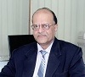 | Q  U  E  S  T  I  O  N  A  N  S  W  E  R  S  E  S  S  I  O  N | Topic: Legal Research Methodology  Speaker: Prof. (Dr.) Kanwal D.P. Singh, Dean, USLLS,GGS IP University | 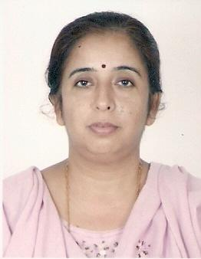 | Q  U  E  S  T  I  O  N  A  N  S  W  E  R  S  E  S  S  I  O  N | V  O  T  E  O  F  T  H  A  N  K  S | L  U  N  C  H
18 July 2017  (Tuesday) |  |  | Topic : Research Problem,Data Collection & Visualization. Reference / Bibliography writing.  Speaker: Prof. (Dr.) Mukul Gupta,  Dean, G. L. Bajaj Institute of Technology and Management | 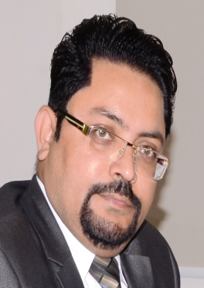 |  | Topic : Fundamental Rights Vs Personal Laws  Speaker: Prof (Dr.) Kiran Gupta, Professor In-charge  Law Center II, University of Delhi | 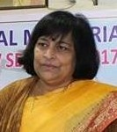
19 July 2017  (Wednesday) |  |  | Topic : Psychometric Test: Personality Assessment of Own Self  Speaker: Prof. (Dr.) Puja Khatri,  USMS, GGSIP University |  |  | Topic : Law in the Making  Speaker: Dr Ravinder Kumar,  USLLS, GGSIP University
20 July 2017  (Thursday) |  |  | Topic: How to write a Research Paper?  Speaker: Prof. (Dr.) Sunil Khatri, Director, AIIT, Amity University | 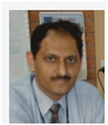 |  | Topic : Inter-disciplinary Research  Speaker: Prof. (Dr.) A. P. Singh,  USLLS,GGS IP University
21 July 2017  (Friday) |  |  | Topic : How to write a Thesis?  Speaker: Prof. (Dr.) Surbhi Singh, Jaipuria School of Business, Ghaziabad | 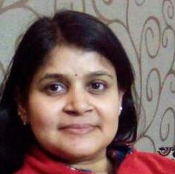 |  | Topic : Domestic Violence In India  Speaker: Prof. (Dr.) Pinky Sharma,  Law Center II, University of Delhi | 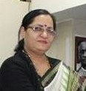
22 July 2017  (Saturday) |  |  | Topic : Qualitative Research Approaches  Speaker: Dr. Vandna Sharma, Birla Institute of Technology Mesra Ranchi, Ext. Centre, Noida. | 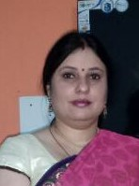 |  | Topic : New Dimension in Public Interest Litigation  Speaker: Mr. O. P. Saxena,  Senior Advocate, Supreme Court | 