THE 1ST CHANDIGARH UNIVERSITY NATIONAL MOOT COURT COMPETITION MARCH 18-19, 2016

ORGANIZED BY
UNIVERSITY INSTITUTE OF LEGAL STUDIES
CHANDIGARH UNIVERSITY
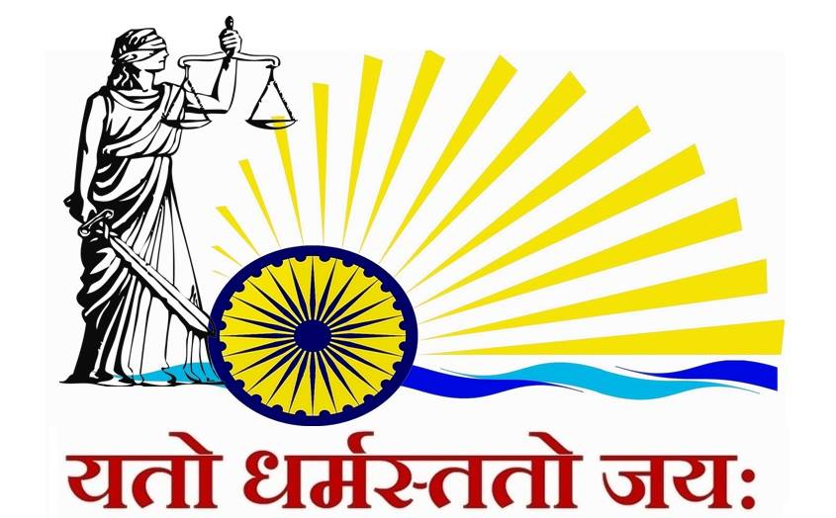

TIME LINE FOR THE COMPETITION

S.NO | CONTENT | DATE AND TIME
 | Registration for the competition, by email at director.uils@cumail.in, puja.jaiswal@cumail.in,  uils.ankita@cumail.in | 05th February, 2016
 | Submission of scanned copy of duly filled registration form, demand draft of Rs. 3000/- (Rupees Three Thousand only) | 15th February, 2016
 | Confirmation of registration/participation | 17th February, 2016
 | Memorial Submission | 25th February, 2016 by 4:00 p.m.
 | Inaugural function/draw of lots/exchange of memorials, etc | 18th March, 2016
 | Round-I (Preliminary & Quarter-Final Rounds) | 18th March, 2016
 | Round-II (Semi-Final & Final Rounds) | 19th March, 2016
 | Prize Distribution/Valedictory Function | 19th March, 2016

AWARDS
1.) Winning Team Award: The winning team will receive a trophy and a cash prize of Rs. 1,00,000/- (RUPEES ONE LAKH ONLY).
2.) Runners-Up Team Award: The runners up team will receive a trophy and a cash prize of Rs. 50,000/- (RUPEES FIFTY THOUSAND ONLY).
2nd RUNNERS UP- The 2nd Runners Up shall be awarded a cash price of Rs. 25,000/- (RUPEES TWENTY FIVE THOUSAND ONLY).
3.) Best Student Advocate/Counsel-The Best Student Advocate/Counsel, shall be awarded a cash price of Rs. 10,000/- (RUPEES TEN THOUSAND ONLY).
4.) Best Memorial/Written Submission- The team making the best Written Submission/Memorial, shall be awarded a cash price of Rs. 10,000/- (RUPEES TEN THOUSAND ONLY).

REGISTRATION FEE
The teams shall be required to send in the duly filled registration form, available at or attached to the information brochure send to the University / Law School along with non-refundable fee of Rs. 3000/- (Three Thousand only) by a demand draft drawn in favour of Chandigarh Educational Trust University Institute of Legal Studies, payable at Mohali.

